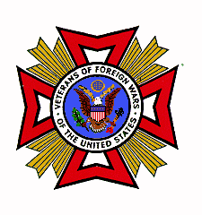
Veterans of Foreign Wars of the US
Department of Washington
5213 Pacific Highway East
Fife, Washington 98424

State Convention Ad Request

The State Convention is scheduled from June 23, 2021 to June 26, 2021 at the Centennial Hotel, Spokane, Washington.

Pricing for the ads will be as follows:

Mark which size (Booklet size 5 ½” x 8 ½” with ½” margins)

a.) Full Page ad - $100
b.) Half Page ad - $ 50
c.) Quarter Page ad - $25 (business card size)

The following information is required:

Name: _____________________________________________________

Type of Ad (Bus/Personal): ____________________ Phone: ______________

Graphics provided for ad: Yes ___ (Please attach) No___

Make checks payable to:
VFW District 9
Memo: June Convention Ad

Send ads to:
Veterans of Foreign Wars,
Department of Washington,
5213 Pacific Hwy E,
Fife, WA 98424

Ads must be received by May 31, 2021.

W. Paul Manly
Quartermaster
509-979-1627

