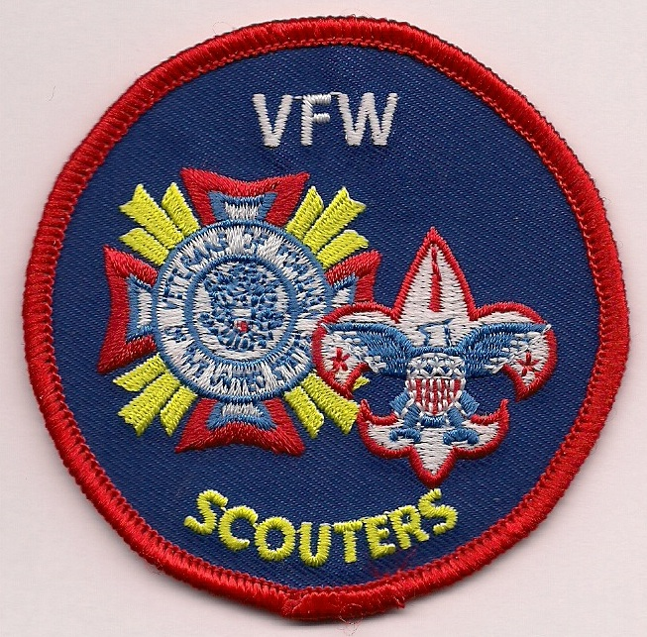
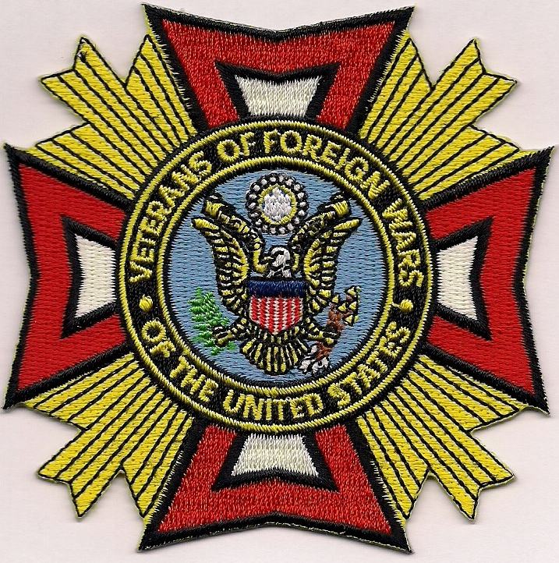
VFW Department of Washington

Scout Team Post of the Year

Selection Process
Possible Points Areas Evaluated

20 A Post member appointed by Post Commander as a Scout Team Member.
(Name must be submitted to State Scout Team Chairman for program communication)
--------------------------------------------------------------------------------------------------------------------- -----------------
10 A Post member appointed by Post Commander as a Post Scout Representative. (Name must be submitted to State Scout Team Chairman for program communication)
--------------------------------------------------------------------------------------------------------------------- -----------------
Max 20 Scout Team Member or Representative provided active support to Department Scout Team. (Level of participation will be determined by the Department Scout Team Chair and Jr. Vice) (10 points each individual, up to two.)
--------------------------------------------------------------------------------------------------------------------------------------
30 Post is officially registered as a BSA Charter Organization for a Scout Unit.
--------------------------------------------------------------------------------------------------------------------------------------
Max 60 Monthly Community Service Reports (CSR) reflecting VFW/Scout activities.
(5 points for each monthly report)
--------------------------------------------------------------------------------------------------------------------------------------
15 Submitted CSRs w/VFW-Scout activity for each of 12 months of Program Year.
--------------------------------------------------------------------------------------------------------------------------------------
30 Submitted Scout-of-Year application to their District by March 1st deadline.
--------------------------------------------------------------------------------------------------------------------------------------
20 Documented promotion of Voice of Democracy/Patriots Pen with Scout Units and Round Tables.
--------------------------------------------------------------------------------------------------------------------------------------
20 Documented promotion of Scout of The Year with Scout Units and Round
Tables.
--------------------------------------------------------------------------------------------------------------------------------------
Max 40 A Post member is registered as an adult leader in a Scouting Organization.
(20 points for each adult, up to two)
--------------------------------------------------------------------------------------------------------------------------------------
20 Post officially sponsors activities involving/supporting Scout Units.
--------------------------------------------------------------------------------------------------------------------------------------
20 Post made monetary contribution to Scout Unit or Department Scout Team for recognitions, awards, training, equipment, etc.
--------------------------------------------------------------------------------------------------------------------------------------
Max Possible Points: 305
Selection Process

May 1st of each year, the Department Scout Team Chair will transfer program data from the Scout Community Service Reports into the areas evaluated above. The resulting tabulation will be presented to the Department Jr. Vice. The winning Post requires approval of the Department Commander and will be recognized at the Department Convention.

Eligibility Criteria

All VFW Posts are eligible for this award. Posts are eligible to win this award for a maximum of two consecutive years. After the second year of winning the Scout Team Post-of-the-Year, that Post will be ineligible to win the following year. After that year, the Post will again be eligible for the award.

(The Department Scout Team can adjust these Criteria with the Department Commander’s concurrence) May 11. 2020

